**VIRTUAL PRIVATE CLOUD (VPC)**

A **VPC (Virtual Private Cloud)** is a secure, isolated network environment within AWS. It functions as a personal data center in the cloud, allowing you to deploy and manage resources with enhanced security and control.

**Why VPC is Important?**

* **Enhanced Security** – Provides a protected network environment for your AWS resources.
* **Flexible Customization** – Allows configuration of IP ranges, subnets, and gateways.
* **Easy Scalability** – Adapts to growing business needs with seamless expansion.

**Key Components of VPC**

**1) Subnets (Logical Network Segments)**

* **Public Subnet** – Houses resources like web servers that require internet connectivity.
* **Private Subnet** – Designed for internal resources like databases that should remain inaccessible from the internet.

**2) Route Table (Manages Network Traffic)**

* Determines the paths that network traffic follows within the VPC.
* Example: Routes internet-bound traffic through an **Internet Gateway (IGW)**.

**3) Internet Gateway (IGW)**

* A component that enables instances in public subnets to connect to the internet.
* Must be linked to the VPC and defined in the route table for internet access.

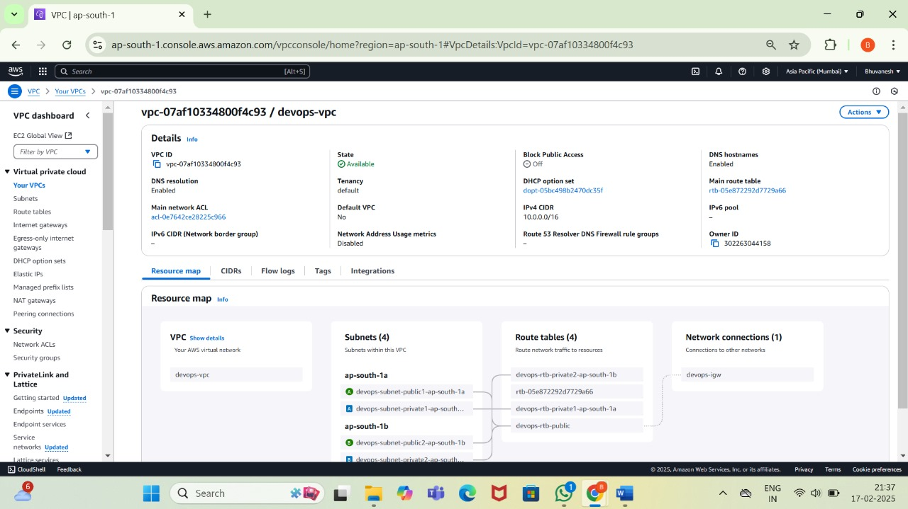

**VPC CREATED SUCCESSFULLY**